ShinyR GUI design and functionality Introduction
This ShinyR GUI is a web-based R GUI. It is implemented with the shiny package developed by RStudio. “shiny” package aims for known datasets, i.e. before bring up the application, the user know its data and variables. The GUI widgets will be fixed after the application is brought up; the number and the name of all widgets cannot be changed.
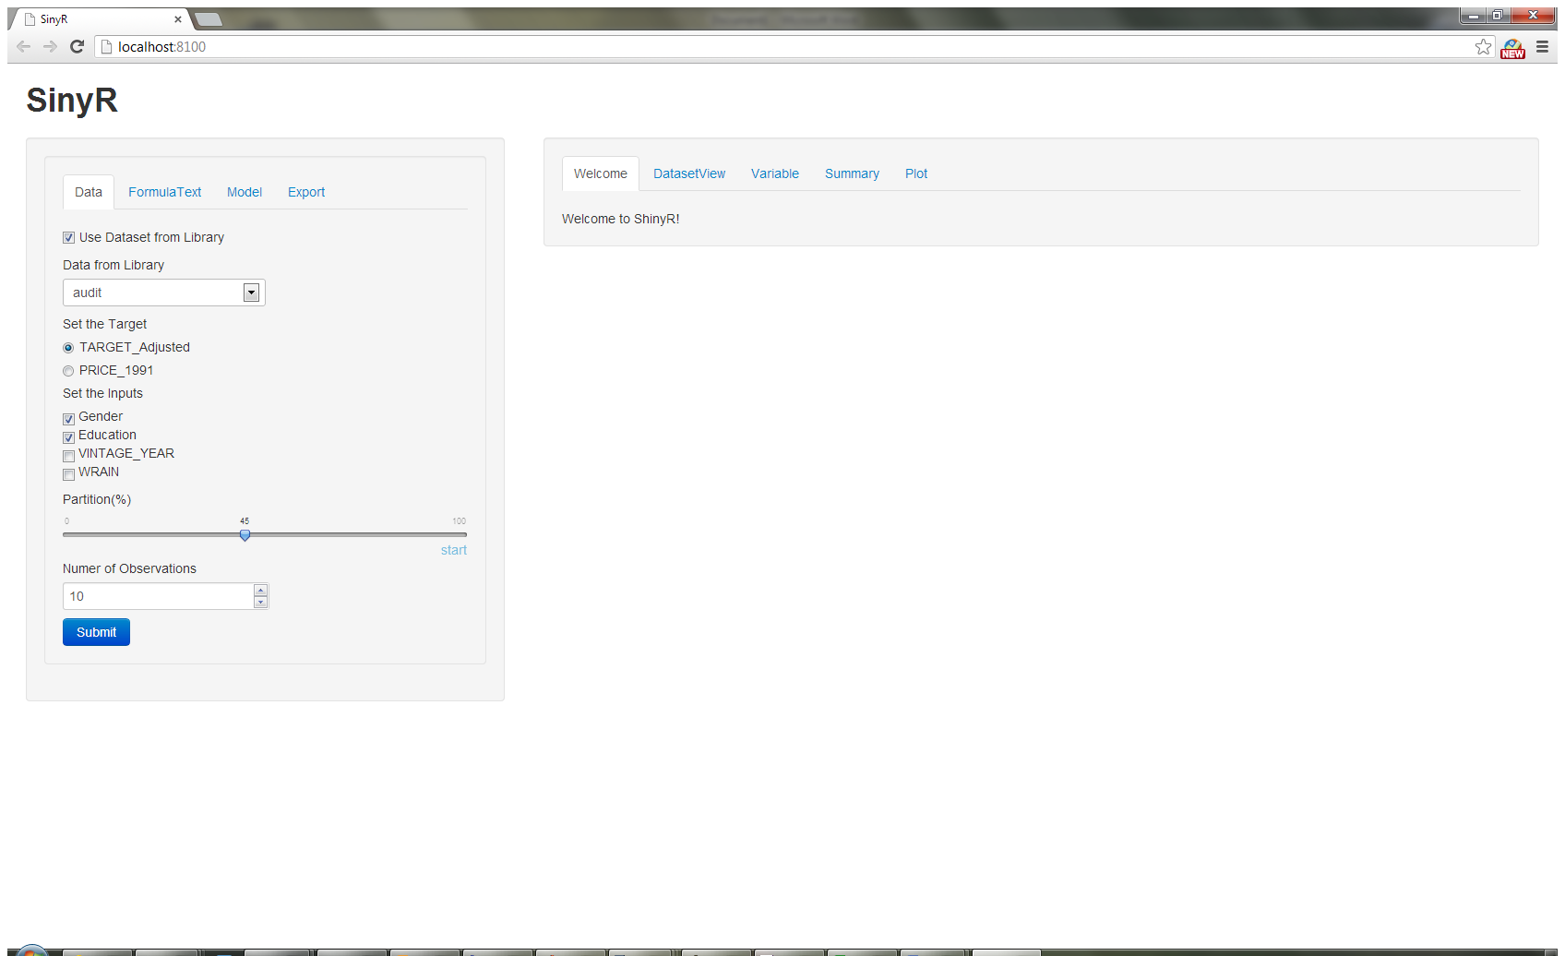
1 GUI components
The ShinyR web-based GUI contains two parts: sidebarPanel and mainPanel. The “sidebarPanel” is for all inputs, including data, variable sets, formula text, model type and export data option. The “mainPanel” is for output, including data view, variable list, model summary, and plot.
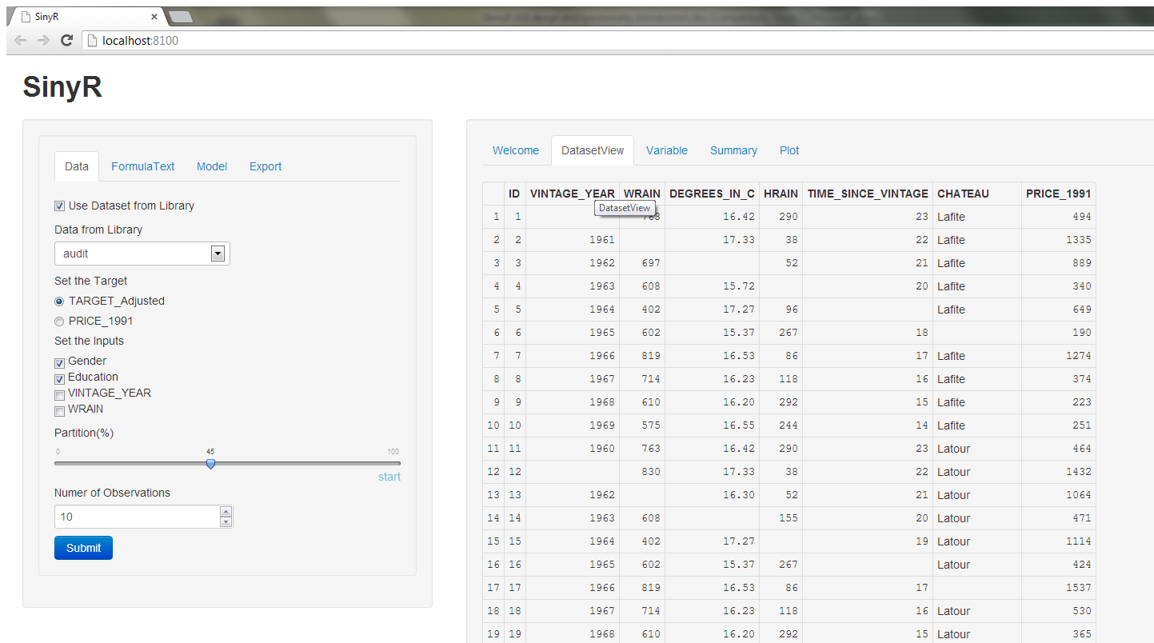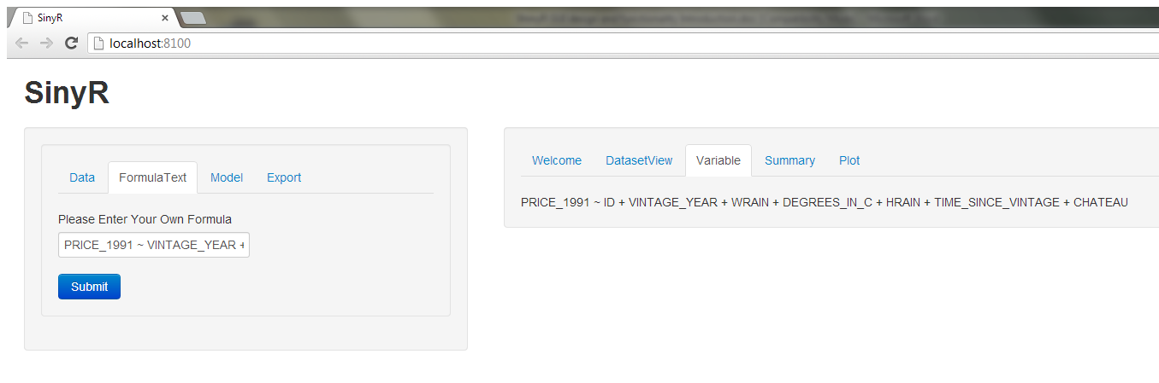
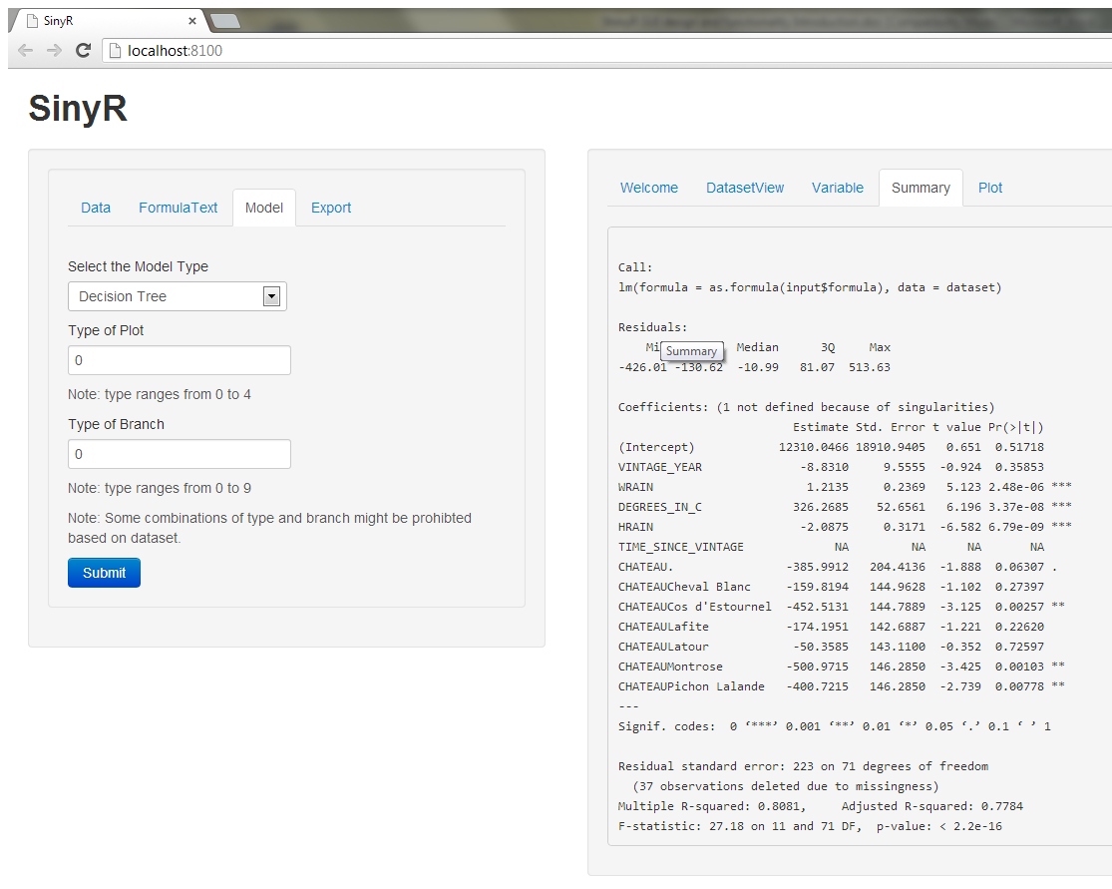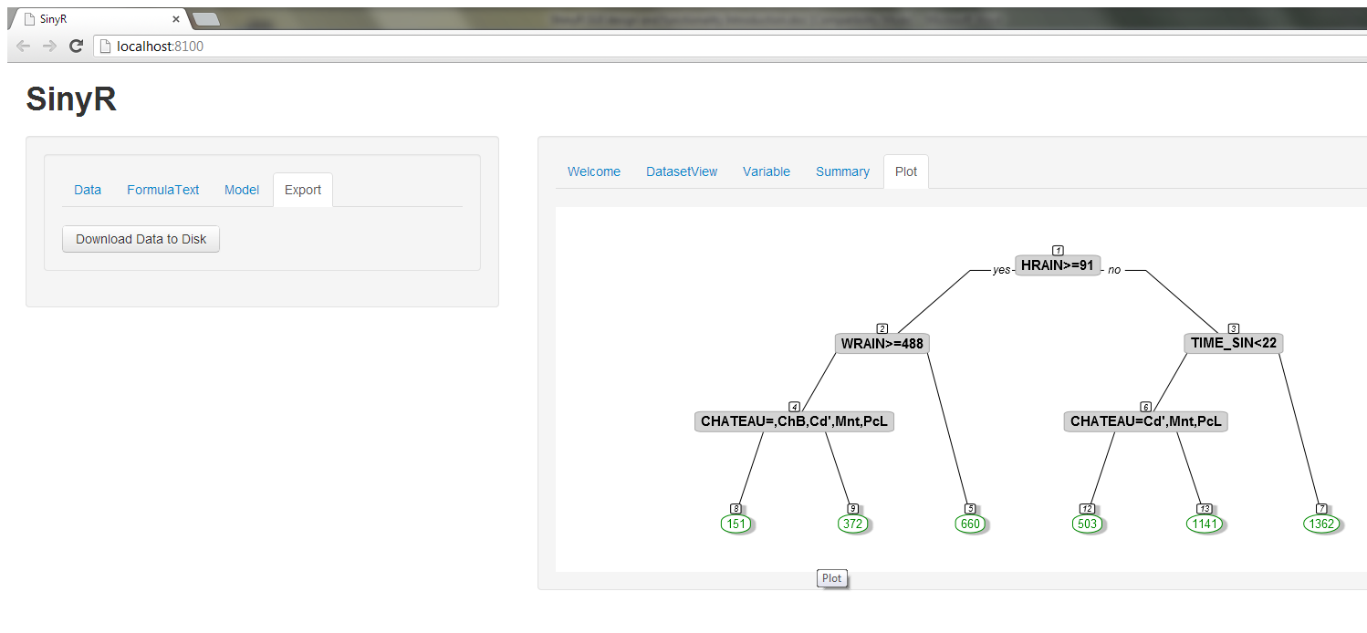

Both “ sidebarPanel” and “mainPanel” are in the form of tabs. The connection among them is not one to one. The submit button in any tab will update the output of the active tab in the “mainPanel”. One can have summary of decision tree but a regression plot for the same dataset.
This ShinyR GUI includes as many as possible of all available widgets in shiny package. ShinyR GUI has check box and check box groups, radio button, text entry box, spin box, dropdown box, help text, download button, submit button, file upload button and a slider with animation option. The download button, submit button and file upload button are like “shortcut” icon which complete the file uploading, downloading and execution in a simple”click”. The slider is for numeric input, here in the ShinyR GUI, it indicates the sampling percentage. The “start” button under the slider is a play button for animation movement of the slider.
2 Data
There are two ways of loading a dataset: from the library and from the local disk. If one chooses from library, the variables for target and inputs will be shown for selection. After setting up the inputs and target, the formula text can be shown in the “variable” tab in the mainPanel.
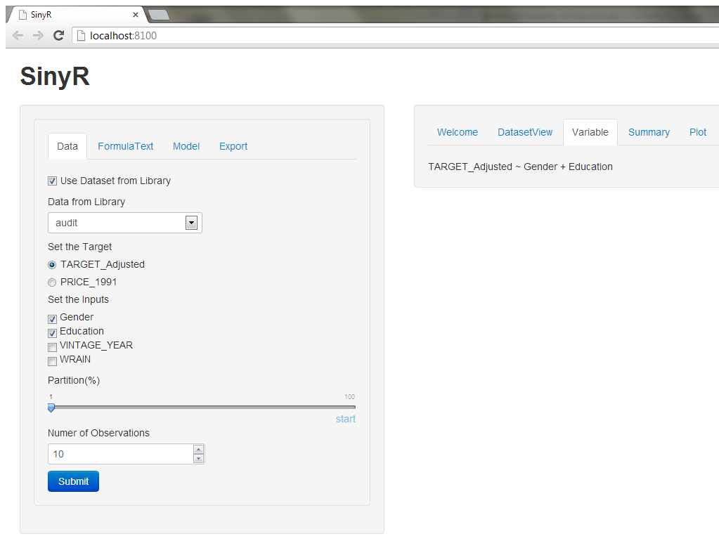
If one chooses from the disk to load a dataset, then no variable buttons will be shown since it is unknown before making the application. But the variable will be shown in the “variable” tab in the mainPanel.
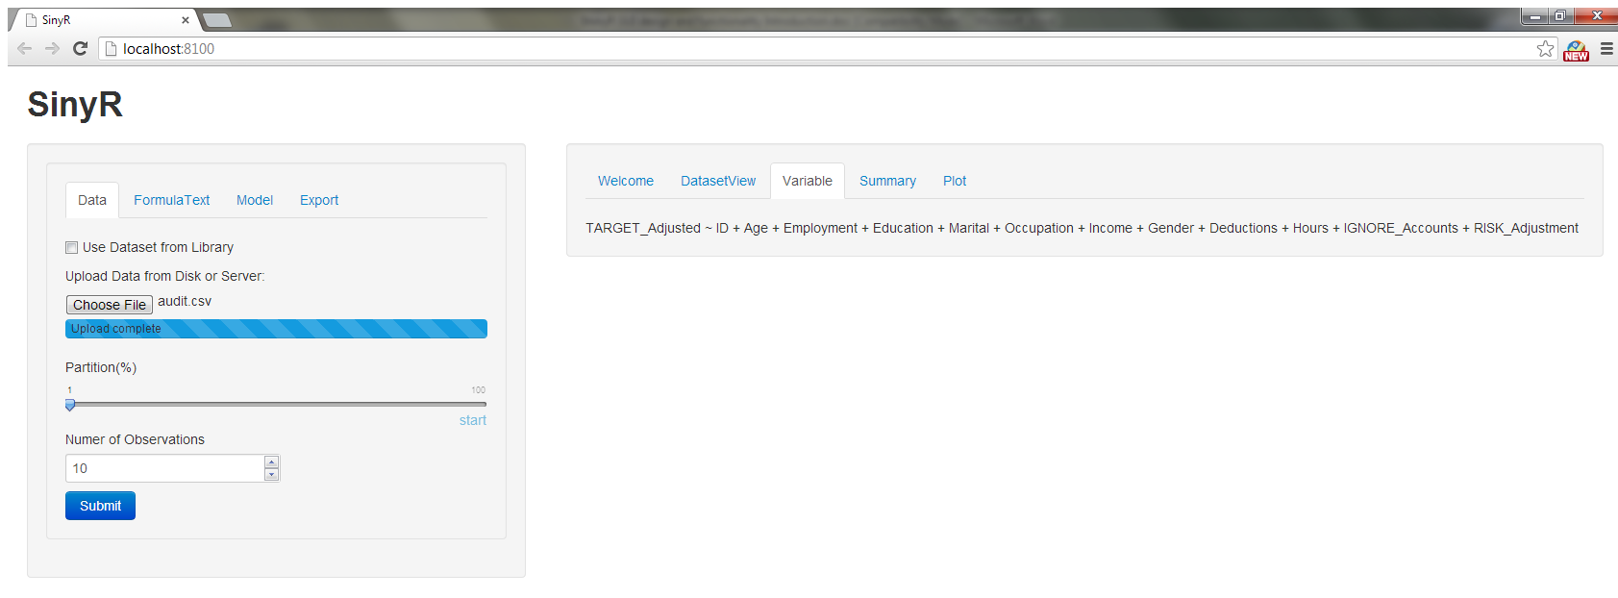
3 Formula
The formula text tab in the sidebarPanel is designed to solve the problem of failure to update the input variable widgets after uploading a dataset from local disk. All variable names from the uploading dataset will be shown in the variable tab and in the form of a formula text. One copy this text into the entry box in the formula text tab and make any modifications they like.
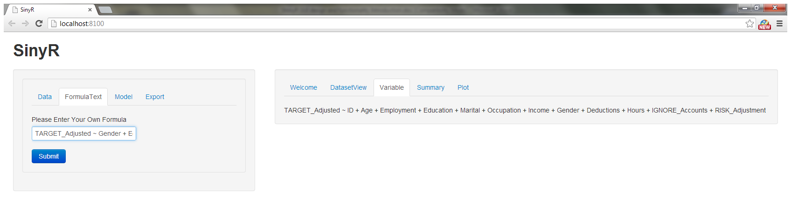
Now after clicking submit button, the model summary or plot will be calculated based on this formula text.
4 Model
There two model types: regression and decision tree for demonstration.
5 Plot Option
For decision tree, the type and the branch entry boxes will appear in the sidebarPanel.
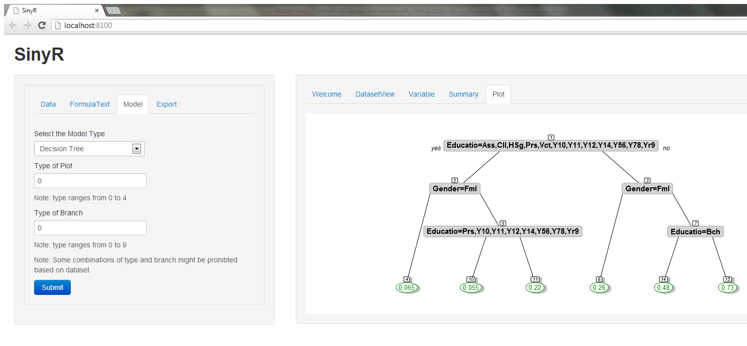
If choosing regression model, the sidebarPanel will hide these two options.
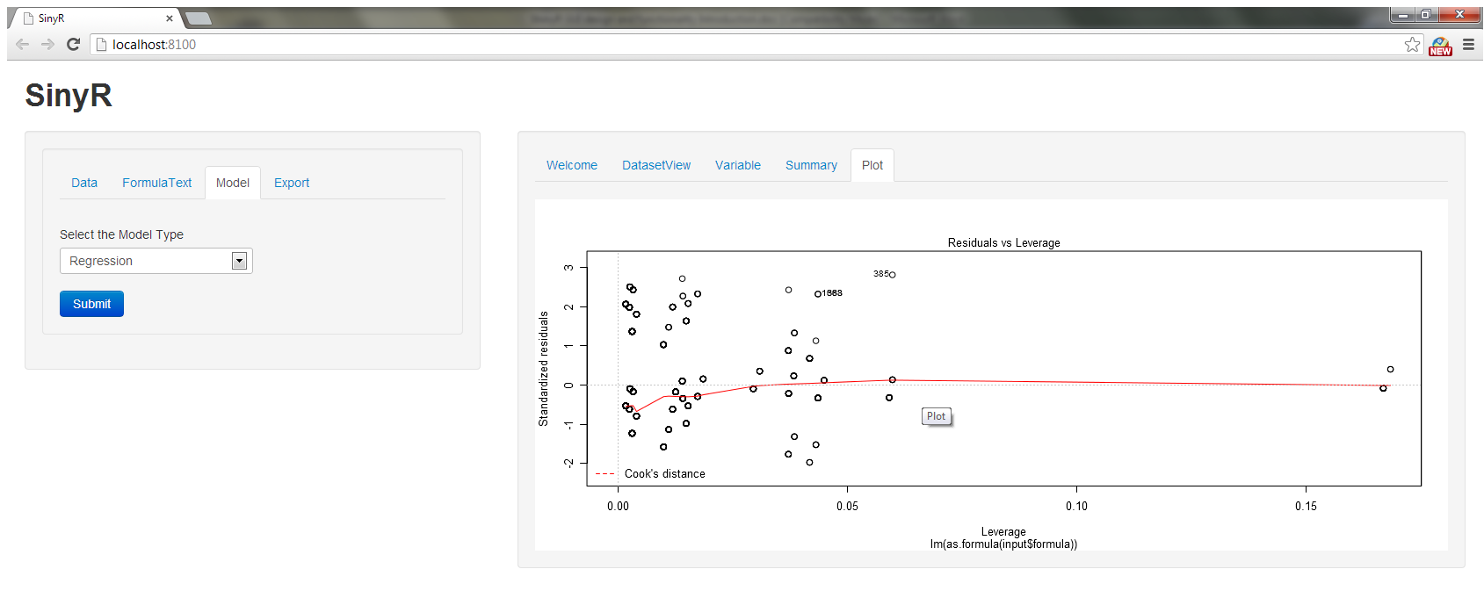
6 Download
This button is for downloading the current active dataset to local disk.
7 Advantages and Disadvantages
Advantages:
- Easy to build and easy to debug
- sidebarPanel tabs are not specifically connected to the mainPanel tabs. You can view any combinations of tabs; submit in any tab will update all.
Disadvantages:
- The inputs and target widgets have to be defined beforehand, no dynamic way in the web-based GUI to refresh it.
- After the application was brought up, R GUI was freezed and cannot be used for any other calculation. Press ESC will resume R GUI but freezes the web application. Resuming the application needs to re run the command line in R GUI.
- All submit buttons are the same.
- Cannot hide the error message

